Title (Time New Roman, Font 12, Bold)
1st author name¹, 2nd author name^{1, *} and Last author name¹ (Time New Roman, Font 10)
¹ Affiliation (Time New Roman, Font 10)
*Corresponding author: Please_fill_in@email.

Abstract
Abstract must be written in Time New Roman, font 10. Abstract should not exceed 250 words.

Keywords: A maximum of 4-11 words, In alphabetical order, Separated by comma “,”. (Time New Roman, font 10, upper case at the beginning of each keyword)

1. Introduction (Time New Roman, Font 10, Bold)

This document is a Microsoft Word template. Please do not use other templates. The author(s) must strictly follow instructions so as to maintain the journal's high standard.
The text must be typed in word format size A4 not more than 15 pages with top, bottom, left and right margin of 1 inch from the border. It should be typed in a single column and a double space. Time New Roman, point 10 for contents. International System of Units (SI) is used for the metric system. Authors full and last name. The middle name should be abbreviated to the initial letter accompanied by a full stop " ". Join each author’s name by the symbol “,” and the last author with “and”. The pages should be numbered at the top right hand corner consecutively. The manuscript has to be divided into three parts. The first part includes the title, name of the author, abstract, and keywords. The second part is the main body of the paper , which includes references and nomenclature. The body of the article may consist of the following sessions.
- Introduction
- Materials and methods
- Results (Results and discussion can be written in one section or separately.)
- Discussion
- Conclusion
- Ethical approval (if any)
- Acknowledgements
- Conflicts of interest
- References
The last part is the appendix (if necessary). This section should include a large table or figure that can not reduce the scale or size.

The main text of the article must be written in Time New Roman, font 10, and double spacing of 12 points. The font size, line spacing, and margin of the template must not be changed.

References should be listed at the end of the paper and arranged in order.

References should be cited in the main text by numerals in a square bracket [No.]. For example:
- Citation less than 3 lists i.e. [1,2], [3], [7,11]
- Citation have 3 lists or more i.e. [4-6], [8,13,15], [11,17-19], [12,13,20]

2. Section (Time New Roman, Font 10, Bold)

2.1 Subsection (Time New Roman, Font 10, Italic)

The second part consisting of the paper body must be edited in single column format. Figures and tables should be located at the top or bottom of each page. Clear original figures in black and white are to be used. Equations should be numbered consecutively throughout the paper and located at the right margin as shown in Equation (1) below. Figures and tables should be placed at the top or at the bottom of each column as shown in Figure. 1 and Table 1. The term "Table" should be followed by a bold typed number. Use the table function of Microsoft Word. Avoid vertical lines and unnecessary horizontal lines. The term "Figure" should be followed by a bold typed number. Symbols, nomenclatures, abbreviations and units should match the figures and text used. The legends of the figure should not be more than 200 words. Composite figures should be used (A), (B), (C), etc. and font Time New Roman to label must be show on top left of the figure.

Table 1 The process yield and physical properties of the microcapsules.
Carriers | Samples | Gac concentrations (% w/v) | Moisture contents (%) | A_{w} | Process yields (%)
Maltodextrin | M1 | 12.5 | 4.42+0.84^{b} | 0.31+0.01^{ab} | 61.72+2.16^{ab}
 | M2 | 16.7 | 3.92+1.12ª | 0.30+0.01^{ab} | 65.33+1.63^{b}
 | M3 | 25.0 | 3.24+1.13ª | 0.27+0.01ª | 69.44+1.48^{b}
Gelatin | G1 | 11.1 | 5.98+1.46^{c} | 0.40+0.01^{c} | 51.69+3.52ª
 | G2 | 20.0 | 5.53+1.08^{c} | 0.34+0.01^{b} | 53.30+2.59ª
 | G3 | 33.3 | 4.80+1.29^{c} | 0.30+0.01^{ab} | 54.19+1.07ª
β-cyclodextrin | B1 | 11.1 | 5.96+1.29^{c} | 0.40+0.01^{c} | 68.28+0.17^{b}
 | B2 | 20.0 | 5.78+1.66^{c} | 0.36+0.01^{b} | 78.38+1.87^{c}
 | B3 | 33.3 | 5.10+1.02^{bc} | 0.31+0.02^{ab} | 75.30+2.38^{c}

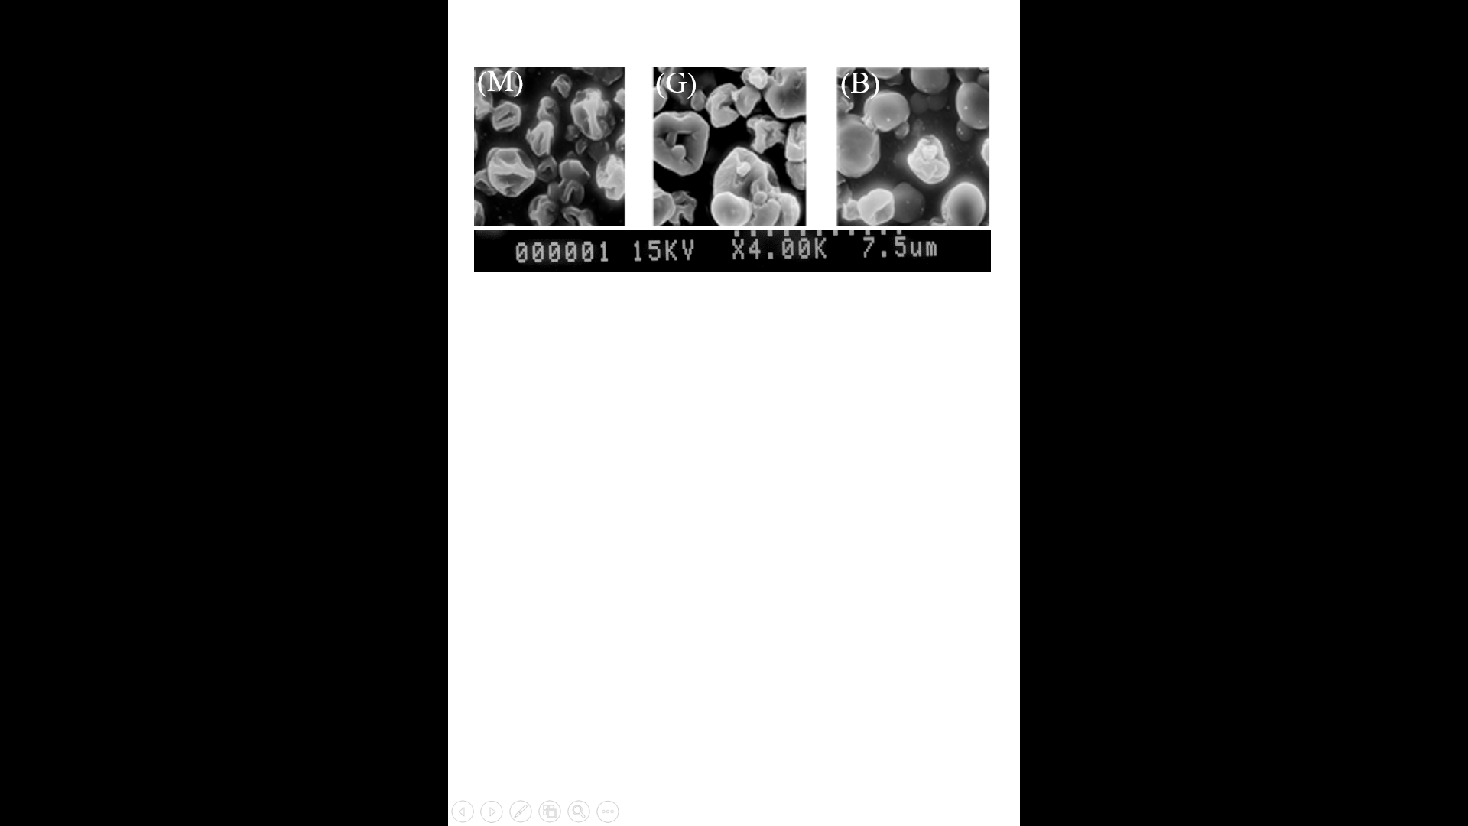
Figure 1 Micrograph of the microcapsules with different Gac aril concentrations, in which M = maltodextrin, = gelatin, and B = β-carotene.

3. Conclusion (Time New Roman, Font 10, Bold)

Clarity of all figures is of the utmost importance. If the final version is not prepared in a format or does not include all the details, the publication process will be delayed.

Acknowledgements (Time New Roman, Font 10, Bold)

This work supported by Research Program supported by the Department of Education and Technology (program name), Country Name. Please also include the Grant number.

References (Time New Roman, Font 10, Bold)

References should be in the Vancouver style, and only in English. Please ensure that all references in the text are also included in the reference list. Use the Arabic number in parentheses after the statement. The maximum number of references shall not exceed 35 articles for Full Length Original Article/Research Article), and 50 articles for Review Article. “Unpublished observations” and “personal communications” are not allowed to be the references. The journal abbreviation can be checked from https:/www.ncbi.nlm.nih.gov /nlmcatalog/journals

- Vuong LT. Underutilized β-carotene-rich crops of Vietnam. Food and Nutr Bull. 2000;21(2):173-181.
- Chan R, Lok K, Woo J. Prostate cancer and vegetable consumption. Mol Nutr Food Res. 2009;53(2): 201-216.
- Choi JG, Kang OH, Brice OO, Lee YS, Chae HS, Oh YC, et al. Antibacterial activity of Ecklonia cava against methicillin-resistant Staphylococcus aureus and Salmonella spp. Foodborne Pathog Dis. 2010;7(4):435-441.
- FAO. Composition of Meat [Internet]. 2019 [cited 2019 Feb 14]. Available from http://www.fao.org/ag /againfo/themes/en/meat/backgr_composition.html.
- OECD. Meat consumption (indicator) [Internet]. 2019 [cited 2019 Feb 14]. Available from https://data. oecd.org/agroutput/meat-consumption.htm.
- Amsler CD. Algal Chemical Ecology. Vol 468. Berlin: Springer; 2008.Eom SH. Anti-MRSA (methicillin-resistant Staphylococcus aureus) substance isolated from Eisenia bicyclis and its action mechanism [Dissertation]. Busan: Pukyong National University; 2012.
- World Health Organization. A global brief on vector-borne diseases. Geneva: WHO; 2014.

